Homework 2 Quarto
Mateo Mori
2026-01-28
library(tidyverse) # load in packages
Warning: package 'dplyr' was built under R version 4.5.2
library(janitor)
lobsters <- read_csv("lobster-catch-data.csv") # read in lobster data
my_data <- read_csv("my_data.csv")

Part 2. Problems

Problem 1
- I collected discrete data to represent the presence of the bunchgrass species across 13 different sites within the oak woodlands. I collected this type of data because it is not categorical and it only takes integer values.
- Standard deviation would be best because it reflects the actual spread of bunchgrass counts in the data. My final answer is 1.9 bunchgrass individuals (count) rounded to 1 decimal point.
bunchgrass_count <- c (4, 6, 4, 5, 5, 4, 2, 3, 6, 4, 2, 0, 1) # saving list of numbers as an object called bunchgrass_count
sd(bunchgrass_count) # caluculated standard deviation
[1] 1.853617
c. Standard error is the better description of uncertainty because it shows the precision behind the bunchgrass count mean. The standard error in this scenatio would represent the average amount I would expect the sample mean to vary from the true population mean if we were to repeat the study multiple times with the same sample size (13). My final answer is 0.5 bunchgrass individuals rounded to 1 decimal point, and this means that our sample mean is relatively precise, and that the true population mean likely falls within a narrow range around our calculated average.
sd(bunchgrass_count)/sqrt(length(bunchgrass_count)) # caluculated standard error
[1] 0.514101

Problem 2

2a.
lobsters_clean <- lobsters |> # introduced lobsters dataframe
clean_names() |> # cleaned lobsters dataframe to only show lower case letters and underscores
mutate(protection_type = case_when( #changed MPA and non-MPA labels to be Marine Protected Area and not protected, respectively.
protection_type == "MPA" ~ "Marine Protected Area",
protection_type == "non-MPA" ~ "not protected"
)) |>
select(protection_type, weight_lbs) # selected only these two columns to be shown in the data frame.
lobsters_clean |> # introduced lobster data
slice_sample(n = 10) # displayed 10 random rows from the two columns of the data frame
# A tibble: 10 × 2
protection_type weight_lbs
<chr> <dbl>
1 not protected 17.2
2 not protected 16.1
3 Marine Protected Area 13.4
4 Marine Protected Area 7.9
5 Marine Protected Area 8
6 Marine Protected Area 5.7
7 Marine Protected Area 5.9
8 not protected 19.1
9 Marine Protected Area 7
10 not protected 13.5

2b.
lobster_summary <- lobsters_clean |> # created new object from lobsters_clean
group_by(protection_type) |> # comparing protection types
summarize(
mean = mean(weight_lbs),
n = length(weight_lbs),
sd = sd(weight_lbs)
) # calculated mean, standard deviation and recorded number of observation
lobster_summary
# A tibble: 2 × 4
protection_type mean n sd
<chr> <dbl> <int> <dbl>
1 Marine Protected Area 8.93 35 2.39
2 not protected 15.5 30 2.89

2c.
ggplot(lobsters_clean, # introduce lobsters_clean dataframe
aes(x = protection_type, # x and y axis using their own column in the dataframe
y = weight_lbs,
color = protection_type, # different colors per protection type
shape = protection_type # different shape per protection type
)) +
geom_jitter( # show data in jitterplot format
height = 0,
width = 0.1,
alpha = 0.6,
size = 2 # change the width of the horizontal jitter spread, the transparency of the points, and the size of each of the points.
) +
geom_pointrange(data = lobster_summary,
aes(x = protection_type, # x is protection type
y = mean, # y is mean
ymin = mean - sd, # lower bound
ymax = mean + sd), # upper bound
color = "black", # add black outline and decrease size a little
size = 0.5,
inherit.aes = FALSE) +
scale_color_manual(values = c("steelblue", "forestgreen")) + # manually changes colors of the two different sample groups
theme_minimal() + # changed theme to not be the default
theme(legend.position = "none") + # removes legend
labs( # creates axis labels
x = "Protection Type",
y = "Mean trapped lobster weight (lbs)"
)
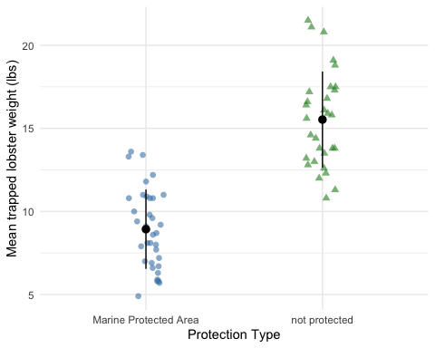

2d.
Null Hypothesis: The mean trapped weight of California spiny lobster is the same in MPA and non-MPA sites
Alternative Hypothesis: The mean trapped weight of California spiny lobster differs between MPA and non-MPA sites

2e.
ggplot(data = lobsters_clean, # indroduced dataframe to be used in the plot
aes(sample = weight_lbs)) + # made y - axis
geom_qq_line(color = "blue") + #
geom_qq() + # create qq plot with the data introduced above
facet_wrap(~ protection_type) # shows protection categories separately
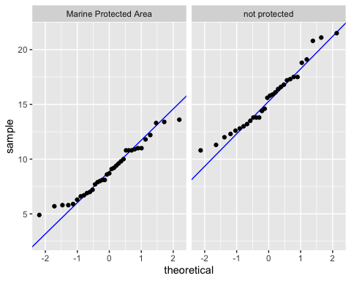

2f.
The variable of interest is normally distributed because the shape of the distribution falls on the reference line in the QQ plot. Not only does the general shape align with the reference line, but the few outliers in the individual lobster weights can be seen as not significant enough to indicate skewness, accepting the data as normally distributed. Both “Marine Protected Areas” and “not protected” groups show these patterns.

2g.
Using the F-test result ($p=0.29$), there is no significant difference in the variance of lobster weights between the Marine Protected Area and non-protected sites, so equal variance can be assumed between the two data sets. This means that the spread of data points around the mean are roughly the same across the two groups, backing up the claim of there being no significant difference.
var.test(weight_lbs ~ protection_type, # compared the variance of the two normally distributed samples, seeing if they are equal or not.
data = lobsters_clean) # introduced the dataframe used for the variance test
F test to compare two variances
data: weight_lbs by protection_type
F = 0.68415, num df = 34, denom df = 29, p-value = 0.2868
alternative hypothesis: true ratio of variances is not equal to 1
95 percent confidence interval:
0.3317467 1.3824429
sample estimates:
ratio of variances
0.6841479

2h.
t.test(
weight_lbs ~ protection_type, # formula: response variable ~ grouping variable
var.equal = TRUE, # argument for equal/unequal variances (variances should be equal)
data = lobsters_clean # data: lobsters data frame
)
Two Sample t-test
data: weight_lbs by protection_type
t = -10.082, df = 63, p-value = 9.084e-15
alternative hypothesis: true difference in means between group Marine Protected Area and group not protected is not equal to 0
95 percent confidence interval:
-7.906409 -5.290734
sample estimates:
mean in group Marine Protected Area mean in group not protected
8.931429 15.530000

2i.
- Using a t-test is appropriate for this situation because we are comparing mean lobster weights between two independent groups (MPA and non-protected) using a continuous response variable.
- Normal distribution was evaluated through the data points following the reference in the QQ plot, and homogeneity of variance was assessed by using an F-test to compare two variances.

2j.
We found a significant difference in mean lobster weight between MPA (n = 35) and non-protected areas (n = 30) (Students t-test, t(63) = -10.08, p < 0.001, a = 0.05).

